Brain Tumor Classification Using AlexNet-Based Deep Convolutional Neural Network and MRI Image Analysis

Prachi Anand
Computer Science and Engineering
Shri Mata Vaishno Devi University
Jammu, India
23bcs064@smvdu.ac.in

Abstract—Brain tumors are among the most dangerous neurological disorders, affecting millions globally. Early and accurate diagnosis is crucial, as delayed detection can lead to severe health complications and lower survival rates. Magnetic Resonance Imaging (MRI) is widely used for detecting brain abnormalities due to its ability to provide detailed, high-resolution images without harmful radiation. However, manual MRI analysis by radiologists is time-consuming and may result in inaccuracies because of image complexity and tumor similarity.
Recent advances in Artificial Intelligence and Deep Learning have significantly enhanced medical image analysis. Convolutional Neural Networks (CNNs) are particularly effective in image classification, as they automatically learn meaningful features from raw data. This study implements an AlexNet-based Deep CNN using PyTorch for multiclass brain tumor classification.
The dataset contains MRI images classified into four categories: glioma, meningioma, pituitary tumors, and no tumor. It is split into training (70%), validation (15%), and testing (15%) subsets using stratified sampling. Preprocessing and augmentation techniques including resizing, normalization, horizontal flipping, random rotation, and cropping are applied to improve model generalization and reduce overfitting.
The AlexNet model is trained with GPU acceleration on Google Colab. Performance is evaluated using accuracy, precision, recall, F1-score, confusion matrix, and ROC-AUC. Experimental results demonstrate that the proposed CNN architecture provides reliable and efficient automated brain tumor classification.
Keywords: Brain Tumor Classification, Deep Learning, AlexNet, MRI Images, Convolutional Neural Network, PyTorch, Medical Image Analysis.

Introduction

Brain tumors are abnormal cell growths within the brain that can severely disrupt normal nervous system function. Early and accurate diagnosis is crucial for effective treatment and improved patient survival. Magnetic Resonance Imaging (MRI) is commonly used for detecting brain tumors due to its ability to produce detailed images of brain tissues and abnormalities.

Traditional diagnosis relies heavily on manual analysis by radiologists, which can be time-consuming and susceptible to errors. Advances in Artificial Intelligence and Deep Learning have greatly enhanced medical image analysis. Convolutional Neural Networks (CNNs) are particularly effective for image classification, as they automatically extract key features from images.

This study implements an AlexNet-based CNN model using PyTorch for multiclass brain tumor classification. The MRI dataset includes four categories: glioma, meningioma, pituitary tumors, and no tumor. The model’s performance is assessed using metrics such as accuracy, precision, recall, F1-score, confusion matrix, and ROC-AUC analysis.

RELATED WORK
Various machine learning and deep learning techniques have been proposed for brain tumor classification using MRI images. Traditional methods like Support Vector Machines (SVM) and K-Nearest Neighbors (KNN) relied on manual feature extraction and achieved limited accuracy.
In contrast, recent deep learning models, particularly Convolutional Neural Networks (CNNs), have demonstrated superior performance in medical image classification. AlexNet introduced a deep CNN architecture that enhanced feature extraction and classification capabilities. Other architectures such as ResNet and VGG16 have also been applied for brain tumor detection. This work employs AlexNet due to its efficient performance and simpler architecture.

METHODOLOGY

Dataset Description

The dataset used in this work contains MRI brain images belonging to four classes:
• Glioma Tumor
• Meningioma Tumor
• Pituitary Tumor
• No Tumor

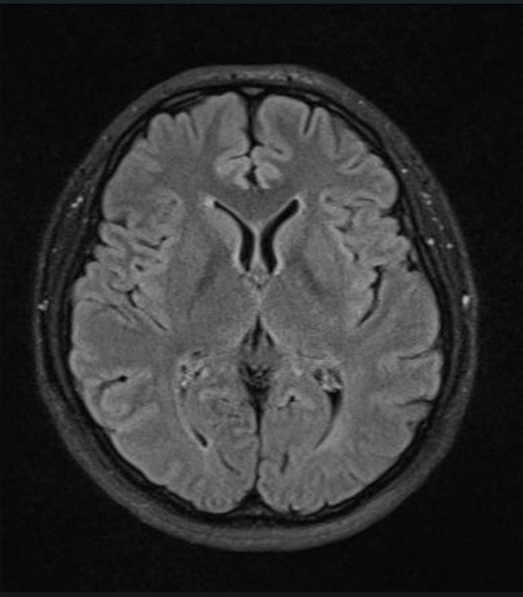
Fig. 1 shows sample MRI brain images from different tumor classes used in the dataset. The dataset contains MRI scans of glioma tumor, meningioma tumor, pituitary tumor, and no tumor categories.

No Tumor

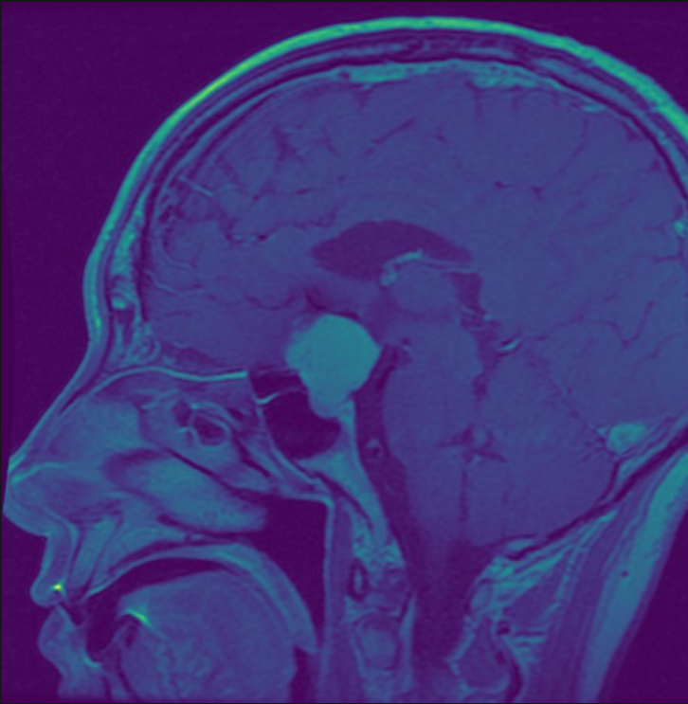

Meningioma

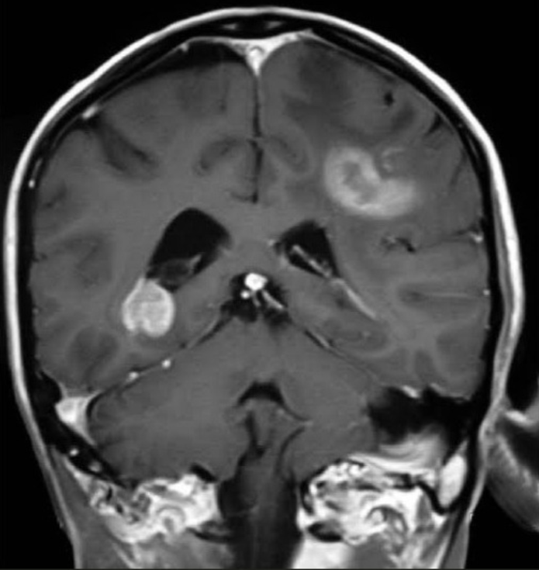

Glioma

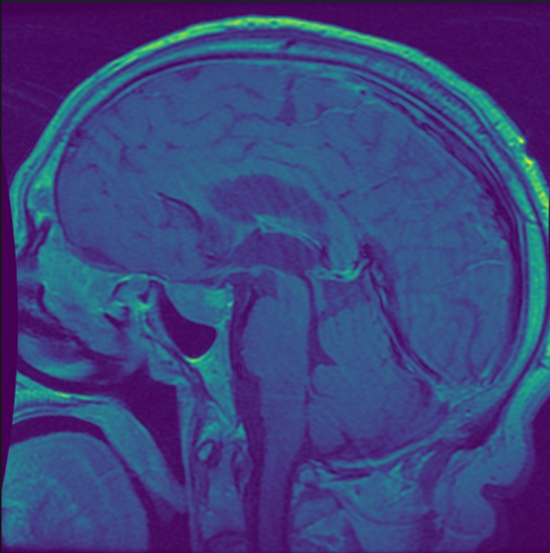
Pituitary

The images are stored in separate folders according to their class labels and are available in JPG and PNG formats.

B. Dataset Splitting

The dataset was divided using stratified splitting:
• 70% Training Data
• 15% Validation Data
• 15% Testing Data

C. Data Preprocessing

All MRI images were resized to 224 × 224 pixels and normalized before training. Data augmentation techniques such as random rotation and horizontal flipping were applied to improve model generalization and reduce overfitting.

D. AlexNet Architecture

AlexNet consists of convolutional layers, pooling layers, ReLU activation functions, dropout layers, and fully connected layers. The architecture extracts important image features and performs multiclass classification.

E. Model Training

The model was implemented using PyTorch and trained using GPU acceleration in Google Colab. The Adam optimizer and CrossEntropyLoss function were used during training.

EXPERIMENTS AND RESULTS

The performance of the AlexNet model was evaluated using different performance metrics including accuracy, precision, recall, F1-score, confusion matrix, and ROC-AUC analysis.

A. Accuracy
The model achieved high classification accuracy across all tumor categories, demonstrating effective feature extraction and reliable prediction capability.

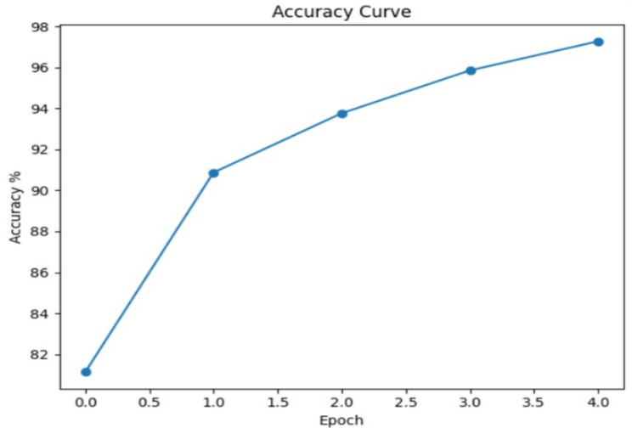

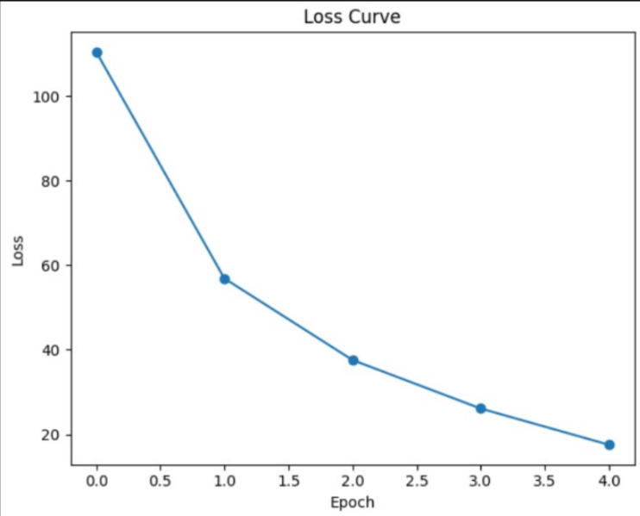

Fig. 2. Training Accuracy and Loss Curve of AlexNet Model

B. Precision

Precision measures the proportion of correctly predicted positive observations among all predicted positive observations.

C. Recall
Recall measures the ability of the model to correctly identify actual tumor samples.

D. F1-Score
F1-score provides a balanced evaluation between precision and recall.

E. ROC-AUC Curve

The ROC-AUC curve demonstrates strong classification capability across all tumor classes. High AUC values indicate that the model effectively distinguishes between tumor and non-tumor MRI images under different threshold conditions.

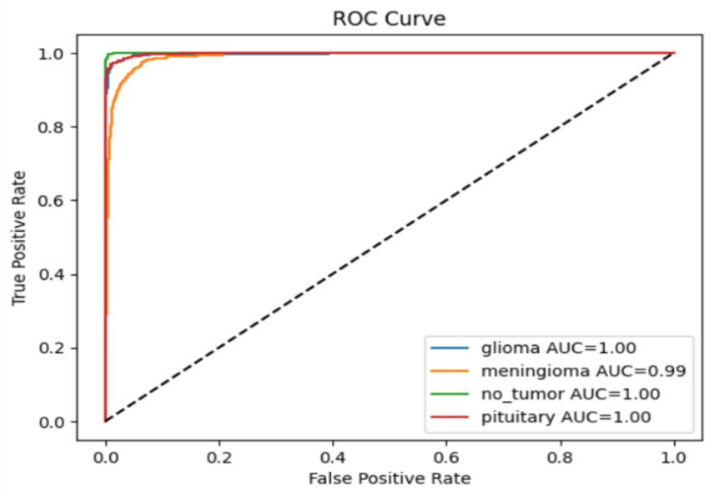

DISCUSSION
The experimental results show that the AlexNet architecture performs effectively in multiclass brain tumor classification. The CNN model successfully extracted meaningful image features and delivered reliable classification across various tumor categories.

Data preprocessing and augmentation enhanced model generalization and helped reduce overfitting. While advanced architectures like ResNet and DenseNet may achieve higher accuracy, AlexNet remains computationally efficient and easier to implement, making it well-suited for educational and research purposes.

CONCLUSION AND FUTURE WORK
In this work, an AlexNet-based Deep Convolutional Neural Network was implemented using PyTorch for brain tumor classification using MRI images. The dataset was divided into training, validation, and testing subsets using a stratified approach. Experimental results demonstrated reliable classification performance across multiple evaluation metrics.
Future work may include larger MRI datasets, transfer learning approaches, real-time deployment, and comparison with advanced CNN architectures.
ACKNOWLEDGMENT
The authors would like to thank the Department of Computer Science and Engineering, Shri Mata Vaishno Devi University, for providing guidance and support during the completion of this project.
REFERENCES
[1] A. Krizhevsky, I. Sutskever, and G. E. Hinton, “ImageNet Classification with Deep Convolutional Neural Networks,” Advances in Neural Information Processing Systems, 2012.
[2] Y. LeCun, Y. Bengio, and G. Hinton, “Deep Learning,” Nature, vol. 521, pp. 436–444, 2015.
[3] K. He, X. Zhang, S. Ren, and J. Sun, “Deep Residual Learning for Image Recognition,” CVPR, 2016.
[4] D. P. Kingma and J. Ba, “Adam: A Method for Stochastic Optimization,” arXiv preprint arXiv:1412.6980, 2014.
[5] O. Russakovsky et al., “ImageNet Large Scale Visual Recognition Challenge,” IJCV, 2015.
[6] I. Goodfellow, Y. Bengio, and A. Courville, Deep Learning, MIT Press, 2016.
[7] J. Deng et al., “ImageNet: A Large-Scale Hierarchical Image Database,” CVPR, 2009.
[8] S. Albawi, T. A. Mohammed, and S. Al-Zawi, “Understanding of a Convolutional Neural Network,” International Conference on Engineering and Technology, 2017.
[9] K. Simonyan and A. Zisserman, “Very Deep Convolutional Networks for Large-Scale Image Recognition,” ICLR, 2015.
[10] M. Tan and Q. Le, “EfficientNet: Rethinking Model Scaling for Convolutional Neural Networks,” ICML, 2019.

